Flash QSPI for MiniZed

1. In the Vivado block design window, ensure the Zynq has QUAD SPI enabled

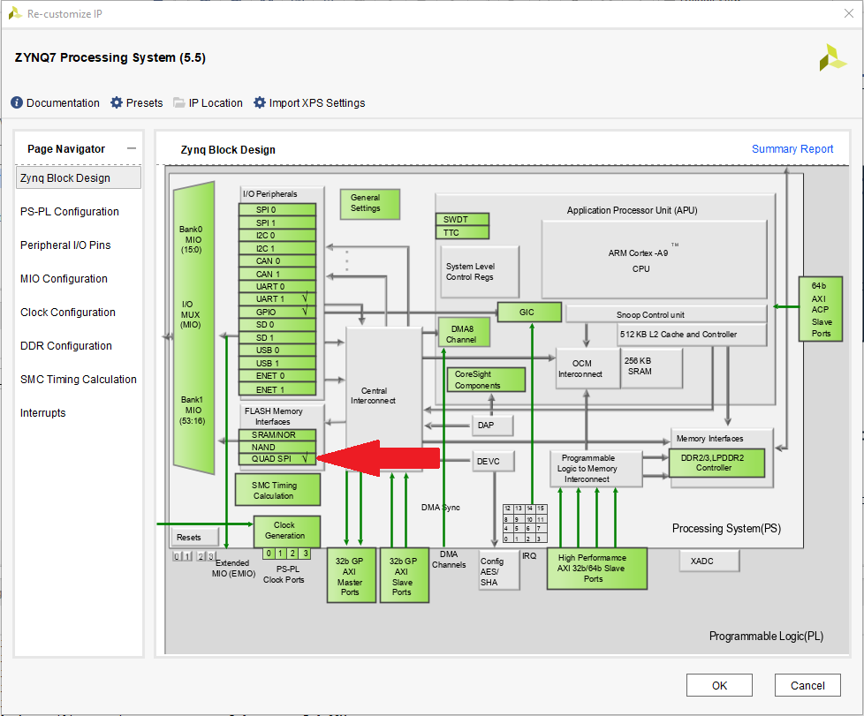

1. Generate and export the .xsa file like normal. I typically save the file in the ‘vivado’ directory.
2. Ensure the BOOT switch is in the J position and then plug in the MiniZed board using the JTAG Micro USB port

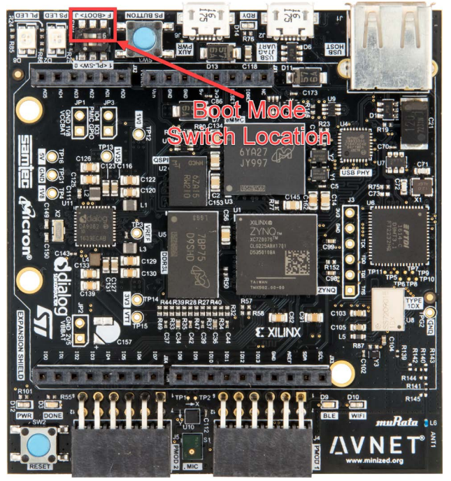

1. Launch Vitis IDE
2. Select ‘Create Application Project’ and click next through the welcome page. This will be the FSBL application you need to flash the QSPI. We will create the actual application project later.
3. Select the ‘Create a new platform from hardware (XSA)’ tab and browse to the location where you saved the .xsa file from step 2, then click next

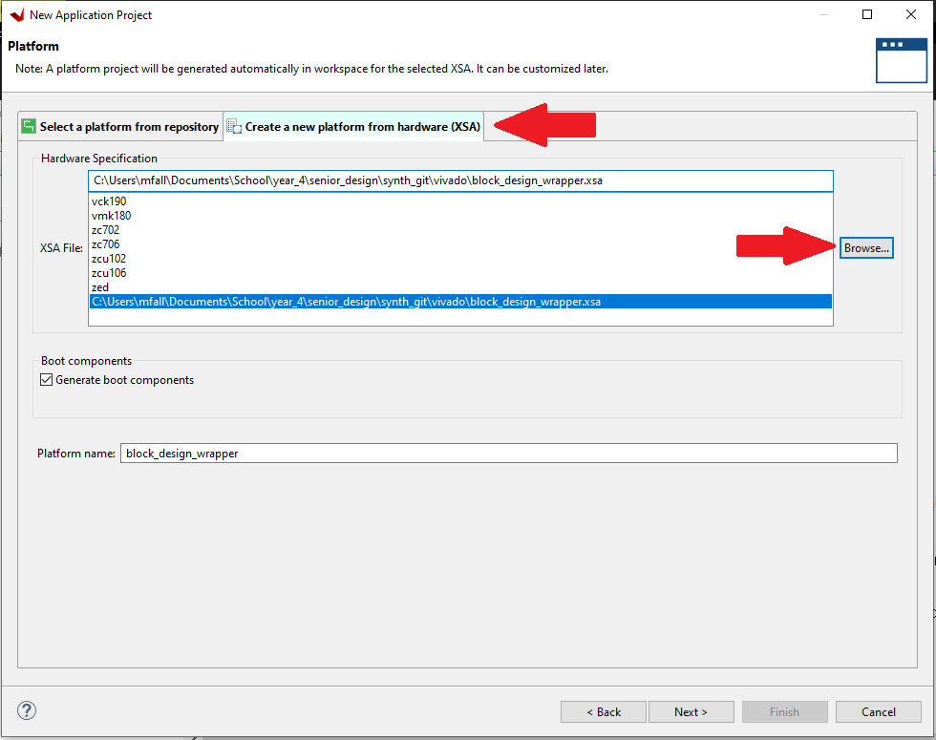

1. Create an application name and append _fsbl to it and click next. In this example, we will name it ‘synth_fsbl’.
2. Click next through the domain select page without changing anything
3. In the Template select page, select ‘Zynq FSBL’ at the bottom of the list and click ‘Finish’
4. Once the fsbl application project has been created, click on the build button and wait until you get a ‘build finished’ message

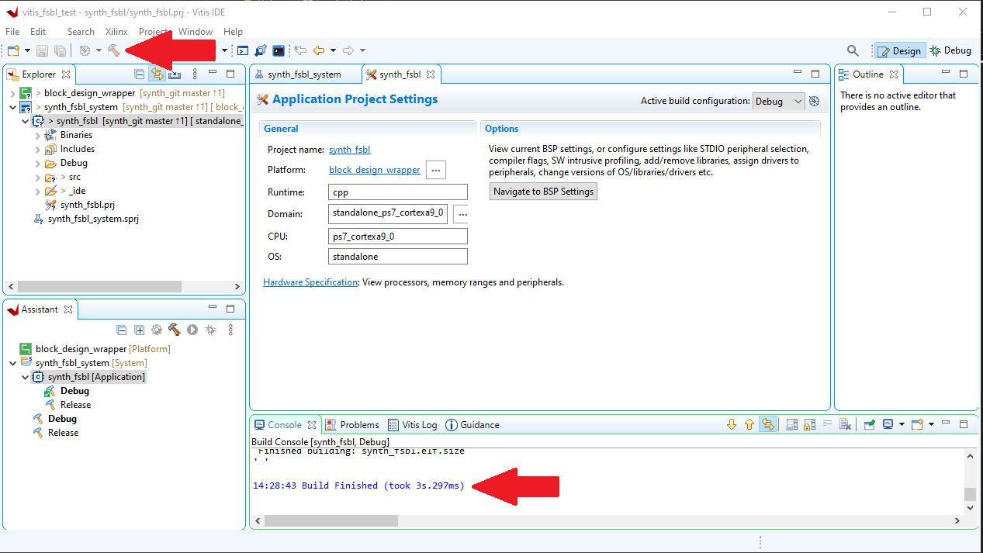

1. Now that the FSBL file has been created, we need to generate the fsbl boot image. Right click on the FSBL application you just created and select ‘Create boot image’
2. in the ‘Output format’ drop down menu, select ‘MCS’, leave the rest of the settings as default and click ‘Create Image’. If a BIF file already exists, click ‘OK’ indicating that you want to override it

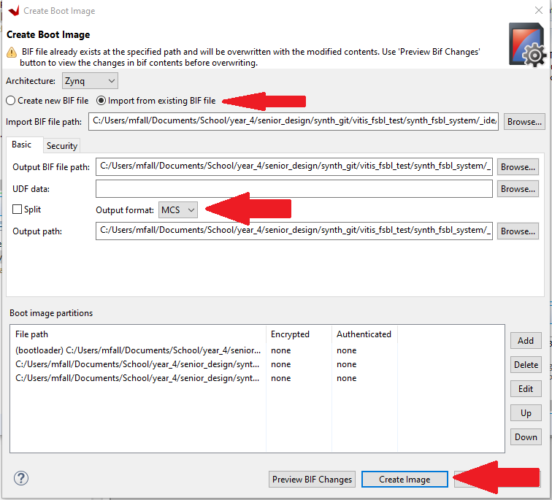

1. Next we need to create the application project that we would like to run on the Zynq.
2. Click ‘File’ -> ‘New’ -> ‘Application Project…’ and click next through welcome page
3. Select the same .xsa file from step 5 and click ‘Next’
4. Name the application project the same as the FSBL project, without the appended _fsbl. In this case, I will name the application project ‘synth’. Click ‘Next’
5. Click ‘Next’ through the domain select window
6. In the Template select window, select the correct template you would like to use. In this case, I will choose ‘Empty Application (C++)’ and click ‘Finish’
7. Once the project has been generated, import the source files into the application project you just created and click ‘Build’
8. Once you receive a ‘Build Finished’ messaged in the console, right click on the application project you just created and click ‘Create Boot Image’
9. in the ‘Output format’ drop down menu, select ‘MCS’, leave the rest of the settings as default and click ‘Create Image’. If a BIF file already exists, click ‘OK’ indicating that you want to override it
10. Next we want to program the flash memory on the MiniZed
11. Click on the ‘Xilinx’ drop down menu at the top of the Vitis page and select ‘Program Flash’
12. Under ‘Project’ select the application you want to run on the Zynq, NOT the FSBL project
13. Under the ‘Image File’ navigate to, and select, the BOOT.mcs file you created in step 20. This should be the boot image associated with the application you want to run, NOT the FSBL
14. Under the ‘Init File’ navigate to, and select, the fsbl.elf file associated with the FSBL application project you created at the beginning. This should be located in the ‘Debug’ directory within the FSBL application project directory. In this case, it is called ‘synth_fsbl.elf’
15. After ensuring the board is connected, click ‘Program’